Lesson 11: Data Representations
GETTING YOURSELF READY
Materials:  Mini whiteboards  Index Cards  Student Handout photocopies  Answers to guided practice completed and photocopied  Graph paper for kids to draw bar graphs |  |  | Your Preparation:  Put last night’s Independent Practice Answer Key and the Misconception to New Understanding Worksheet on a table for students to pick up on their way in to class. |  | Agenda with times:  Do Now and Purpose: 5 minutes  Building the Skill: 10 minutes  Structured Practice: 20 minutes  Guided Practice: 10 minutes  Closure: 5 minutes
GETTING YOUR STUDENTS READY
*Do Now:
Use the answers to last night’s homework problems to correct your homework problems. If you got a 100%, you may write 100% on the top and turn it in. If you got any wrong, you will need to record in your agenda book which problems you got wrong, and tonight, you will need to complete a Misconception to New Understanding for the trickiest problem they got wrong

Solve the Do Now problems on the Student Handout. Be sure to discuss each answer and have the students pair share how they found their answer. Then, cold call on a student to explain how they used the graph to answer the question. This will give you a good idea of how much the students already know about bar and line graphs before the lesson.
Objective: Today you will be able to understand how to represent data pictorially and understand how to visualize a word problem. |  |  |  | Proving Behavior: By using visualization to solve word problems requiring the representation of data.
Purpose: Bar graphs and other representations can help us make better sense of numbers. Representations are great for visual learners.
Key Vocabulary: (from Glencoe.com)
Place these words on vocabulary cards with an image to represent them. Hang them on a Word Wall in the front of the room.
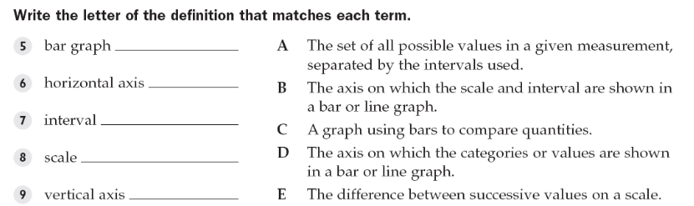

BUILDING THE SKILL
Interpreting a Bar Graph | Say/See: Think aloud how to examine a bar graph. Point to the title of the graph, the x-axis categories and title, the y-axis scale and title and how to read each bar.  Do: Have the students complete 1-4 with a partner as a whiteboard drill. If the students struggled with the Do Now, think aloud problems 1-4 and then have the students partner teach 1-4. Then, have them work with a partner on 5-8 as a whiteboard drill and then complete 9-12 on their own as a whiteboard drill.
Creating a Bar Graph | Say/See: Think aloud and show the information given in the chart.  Do: Have the students discuss each question, one at a time, then share their thinking. Think aloud the final answer that everyone will write on the line.  Say/See: Think aloud how to create the bar graph for problem 5. Have the students just watch and listen.  Do: Have the students partner teach how to create the bar graph for number 5 and fill it in as they are doing the teaching part. Then, have them complete problem 6 on their own, compare their work with a partner, and then show you their work.
Scatter Plot | Say/See: Think aloud the scatter plot—graphing the points, noting the upward or downward trend, and continuing the points to determine future points. Also, short lesson on correlation and causation: show picture of pirates v.s. global warming graph  Do: Have the students complete the practice scatter plot with a partner.
PRACTICING THE SKILL
*Structured Practice
Time: 5-10 minutes  Materials: poster paper  Group Size: 2-4 students  *This is optional based on time and student need. |  | Have each person create a bar graph (using graph paper), but based on data they collect within the classroom. Allow them time to come up with a question (e.g. breakfast foods) and ask fellow peers in the class. Compile data into a bar graph.
Time: 5-10 minutes  Materials: Word Problems  Group Size: Pairs  Materials: Mini Whiteboards |  | Whiteboard drill problems from the sections. If proficient, kids can do the rest. Otherwise, whiteboard the rest.
*Guided Practice (the proving behavior of the objective monitored by teacher)
Assignment: Guided Practice Handout. Have the students complete the remainder of the word problems. Make sure they show their visualization for each problem. |  |  |  |  |  | Criteria for Mastery: 80% of the remaining problems.
Explain Homework: Independent Practice Handouts.
*Closure: Think of one question you want answered that can be visualized using a bar graph. For example, if you want to see grades of the students at BT, which can be visualized using a bar graph.

